1

45 pts. In your last class, your instructor went out of his way to give an example as to why you can’t total (or average) things that are already percents or averages on a line item. We are about to prove this using the following file in this problem. Access the file njed.xls.

Now, this file lists the colleges in NJ. Each college is defined by a designation, the number of full and part time undergraduates and the number of full and parttime graduate students. The designations pertain to whether the school is private or public, a community college or 4 year, religious or secular.

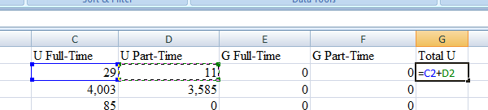Now, we are going to do this two ways; one by subtotals, the other by the new table construct into a pivot table . Notice that sheet1 and sheet2 are the same. Sheet1 will be done by subtotals, sheet2 as combination of the new table construct and pivot table. However, for subtotals, we will not do as much as what we will do with pivot tables. Starting in sheet1

* 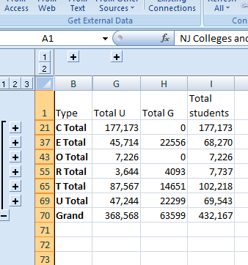For each line item, create 3 new columns. One column to determine the number of undergraduates in the school which you calculate by adding the part time and full time undergraduates together. Similarly, create a column for graduate students adding together the part time and full time graduate students together. Finally, create a column adding these two new columns together which would be the total number of students in the school. By time you are done you have three new columns indicating total number of undergrads (both p/t and full), total number of graduate students (both p/t and full) and total number of students (both undergrad and grad)
* Now, we want to find out the number of undergraduate and the number of graduate students in the state of New Jersey for each of the categories C,E,O,R,T,U. To get subtotal ready to do this, what column should we sort on? ___________ .Do the sort as you indicated above. (remember, the rule of thumb is that you sort on what you will break in subtotals)
* Now, run subtotals to determine the total number of undergraduate students, total number of graduate students and total number of students for each category, C,E,O,R,T,U. Remember to check the appropriate boxes so that undergraduate and graduate students totals both appear. If you have done this right, total students should already be clicked on.

Now, On to pivot tables.This will be on the next sheet of info. First things first. Set your data into a new table construct. There was 2 ways we did this in class and you can do whichever way you would like. You will have 4 new columns to calculate and you can make provision for this at the time of invoking the new table construct or as you need to (since we also showed both ways in class). Further, set the table format as you like.

1. 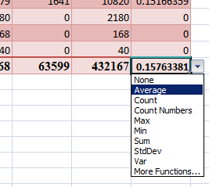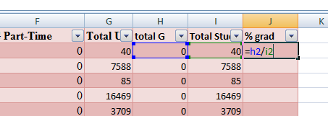On this sheet, in the new table construct, calculate 4 new columns. One column to determine the number of undergraduates in the school which you can calculate by adding the part time and full time undergraduates together. Similarly, create a column for graduate students adding together the part time and full time graduate students together. Continue by creating a column adding these two new columns together which would be the total number of students in the school. Now, add a fourth column – and this is different from subtotals above –that calculates the percentage of graduate students attending each school. This calculation is the total number of graduate students divided by the total number of students in the class.
2. Using the new table construct’s ability to show a total row, determine the average of the average you have just calculated (the average of the fourth new column)
3. Let’s create a pivot table from our table. Determine the number of undergraduate students, graduate students and total students for each category, C,E,O,R,T,U. Note: these number should correspond to what you calculated above in subtotals and you should also see grand total numbers.
4. 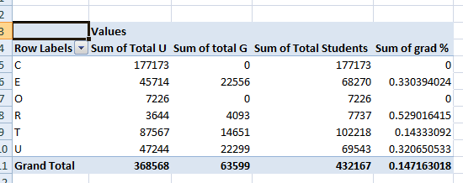Finally, create a calculated field defined as the number of graduate students divided by the total number of students. In essence, you are doing the percentage calculation on a group basis that you did above for each college.

Look at the number you showed in the total row in part ii and the number you calculated here. You should see a difference. Save this file to your machine (or flash memory) and at some time during the test, Email this file as an attachment to 777rauer@voicenet.com

2In the **weight.xls** file are the names and before weights (**bgn wt**) and after weights (**end wt**) for 100 subjects subjected to five classes of weight reduction. In this sample the subjects could choose one type of plan – weight lifting, aerobic exercise, pilates, dieting (no carbs, high fiber) or an experimental medicine.



We want to determine the average reductions of body weight index (BWI) for each type of weight reduction method. BMI is a new standard being used to determine the degree of heaviness. The formula works as follows: 703 * (times) weight in pounds / (divided by) square of height in inches.

Take your instructor as an example. Weight 159 pounds and 68 inches tall. Brown eyes and quite a bit of muscle thanks to his summer exercise plan at Bally’s Fitness. His BMI is 703 *159/(68*68) = 24.2. Anything between 25-30 is considered as overweight. Try to measure your own BMI before trying this problem. Don’t be disappointed if you end up as being designated as overweight. Almost everybody is! Watch it if you are over 30 – this is considered unhealthy.

1. Create three new columns – before and after BMI and the difference. Use the formula to create a BMI factor for the starting weight for each subject and a BMI factor for the ending weight. Your file already has the square of height indicated for each line item. Create a third column by subtracting the 2 factors. Format these 3 new columns to 2 decimal places
2. Create a pivot table showing the average reduction in BMI for each of the regimens. Once you get it, sort this pivot table in decreasing order to show the best regimen first.
3. Create a pivot chart from this pivot table.

 Save this file to your machine (or flash memory) and at some time during the test, Email this file as an attachment to 777rauer@voicenet.com.

3

25 points.The Famous Name Deli has the following part time workers (perhaps you can understand the name of this Deli by this list). You are asked to calculated their approximate take home pay (gross earning after taxes) . Do this as we did the Big V auto dealership

|  |  |  |  |  |
| --- | --- | --- | --- | --- |
| Last Name | First name | Hours worked | Salary/hr | 1=Resident |
| Bond | James | 600 | 20 | 1 |
| Fleming | Ian | 900 | 17.5 | 0 |
| Kent | Clark | 1050 | 75 | 0 |
| Wayne | Bruce | 200 | 25 | 1 |
| Potter | Harry | 600 | 15 | 1 |
| Solo | Han | 1000 | 35 | 0 |
| Jones | Indiana | 700 | 20 | 1 |
| Calahan | Harry | 300 | 25 | 0 |

Included in this table is the number of hours worked and the rate per hour. Yearly totals therefore are Hours worked multiplied by Salary/hr.

* In a new workbook in excel, enter this information
* In a new column, calculate total earning for the year. Note: This is gross earnings and is defined as hours worked multiplied by rate per hour as indicated above.
* One tax that is paid is Social security (FICA on our paycheck) This tax is 7.65% of gross earnings Create a new column indicating the social security taxes paid by each employee.
* Another tax is State tax, taxed at a 2.8% rate on gross earnings. However, State tax is not collected if gross earnings is less than 8000. Create another column calculating state tax keeping in mind that these employees must make more than 8000 to pay state tax. Those below do not pay any tax. Note: *Do this by excel formula. One possibility is using the excel if statement to test if salary is above 8000*
* Another tax is city tax, taxed at 4% for residents, 3.75% for non residents. Each employee has a designation of 1 if resident or 0 if non resident. Calculate each employee’s city tax. *Do this by excel formula. Again, this is most easily done by the use of an if statement to test the 1 or 0*
* A final tax is Federal wage tax (FWT on your paycheck). The tax is 13%
* Net salary (also known as take home salary) is defined as gross salary minus all the taxes. Determine net salary by taking gross salary and subtracting your answers for social security, state tax, city tax and Federal wage tax.
* Create totals in a new row at the bottom of the table for the numeric columns so that we can see total gross salary, total FICA,State,City and FWT taxes and Total net salaries for all the employees. Designate this as Total in the last name for this new row.
* Create a new column to calculate the percentage of salary netted for each individual. This is the ratio between net and gross salaries. (Hint:divide net into gross).
* Format the numbers of your table appropriately. Perhaps currency would work. Whatever you choose, format the numbers to 2 decimal places.
* Finally, group his table appropriately so that one view shows the original info plus net salary, the other view shows all the columns.

Save this file to your machine (or flash memory) and at some time during the test, Email this file as an attachment to 777rauer@voicenet.com